button.close{-webkit-appearance:none;padding:0;cursor:pointer;background:0 0;border:0}.

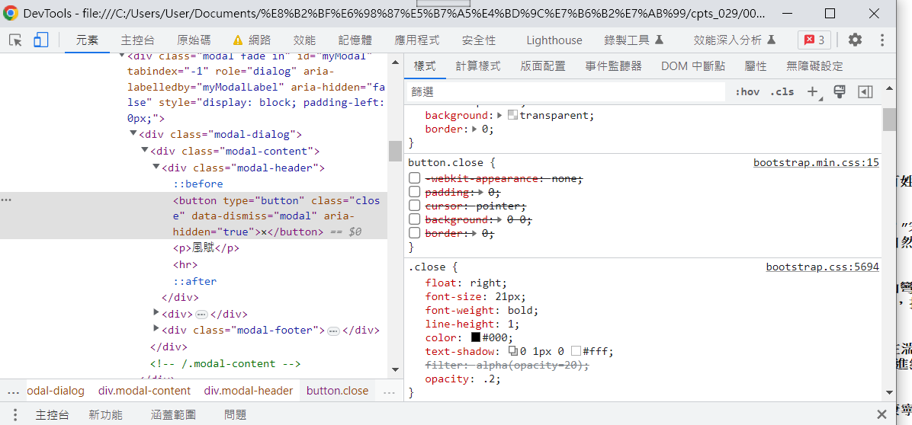

(5712)~
button.close {
-webkit-appearance: none;
padding: 0;
cursor: pointer;
background: transparent;
border: 0;
}
